Add cover Add comment

**No Fear Of Losing**

Why LosinQ On Trades Won't Affect Your Profitability

*1* What Trading With Fear Of Taking Losses Actually Does To Your Trading: Staying concerned about taking a loss promotes Fear Based Decision Making. Equity that is managed by Traders that can not take a loss - can't profit long term. Losing is inevitable - Fear Based Decision Making keeps focus on the adverse.

Fear Based Decision Making fosters Trader Paralysis or inability to execute efficiently.

1 Why Profits Are Achievable Despite Taking Reasonable Losses:

The Professional Equity Manager understands "Losses are costs of doing business." Using sound Equity Management & High Probability Setups yield handsome % returns.

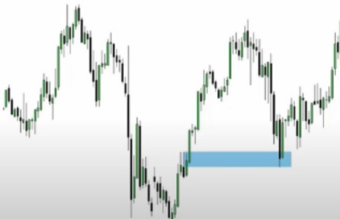

The Market Returns To Previous Institutional Buying - Noted By The Down Condie PriOf To The Previous Price Rally.

Noting The Down Condie Or Bullish Orderblock:High To Open Price Defines The Fair Value Gap

-Or Most Probable "Support".

**Fair Value Gap**

Trading scenarios that encourage potential 3:1 Reward Ratios, provide initial foundation.

Defining Trade Setups that frame 5:1 Reward to Risk or more - efficiently cover losses.

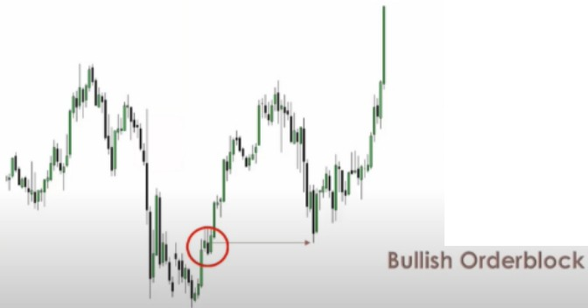Note the open to high on the orderblock, thats the fair value gap, the highest probability support

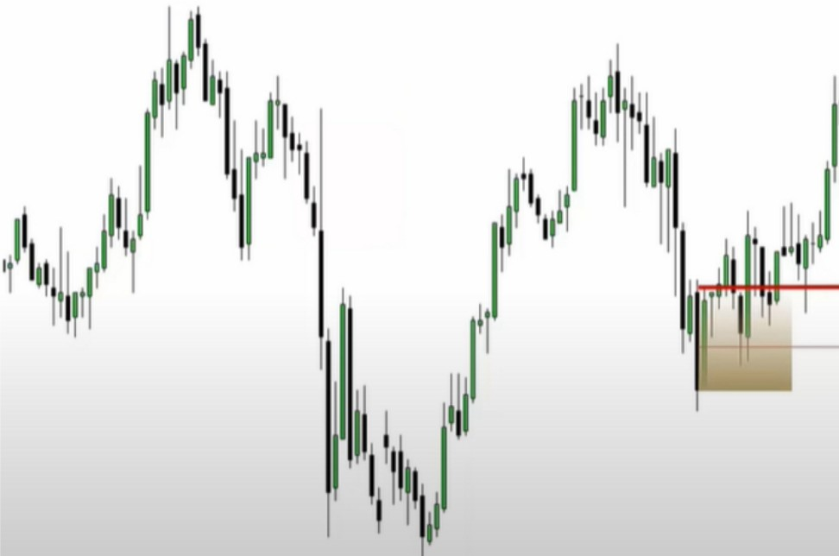

Mean Threshold & Hypothetical Long Entry On Secondary Bullish Orderblock



We dont want to see the mean treshold of orderblocks get violated with bodies 1% risk makes millionaires

2% risk is the industry standard

**Consider The Numbers...**

Wins Losses Account Size: **$5000.00**

50% 50% Accuracy Rate: **50%**

5 Wins In l 0 Trades 5 Losses In l 0 Trades Reward To Risk: **5:1 Ratio**

Aver. Profit= $250.00 Aver. Loss= $50.00 Risk Per Trade: **1**%

Sub Total = $1250.00 Sub Total= $250.00

Average Win: **$250.00**

Average Loss: **$50.00**



**Net Profit= $1000.00**

**20% Return**

Optimal Trading G

Your accuracy will increase with experience

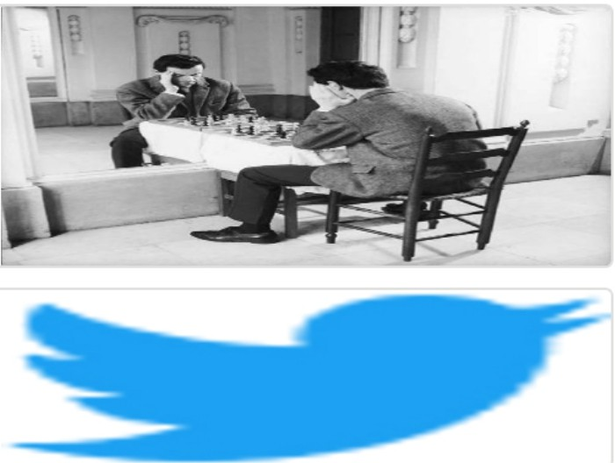Arjo I Twitter, lnstagram I Linktree

Linktree. Make your link do more.

, https://t.co/HhmmTN1fUI

JavaScript is not available.

***"!I*** https://twitter.com/arjoio